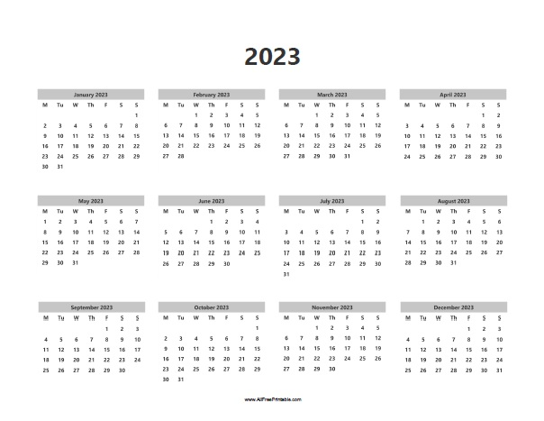

**CICERO RECYCLING CALENDAR**